In-class exercise

Design of the home security system where a user can interact with an interface. If the alarm is triggered a alert message to the user mobile, siren will be triggered and lights will be switched ON. User will be able to delay the triggered alarm.

Assumptions made:

1. User :
   1. Can enable or disable the system.
   2. Can delay the alarm.
2. System :
   1. Control the sensors and alarm.
   2. Send message to user.
   3. Controls lights when activated.

UML class diagram for the home security system.

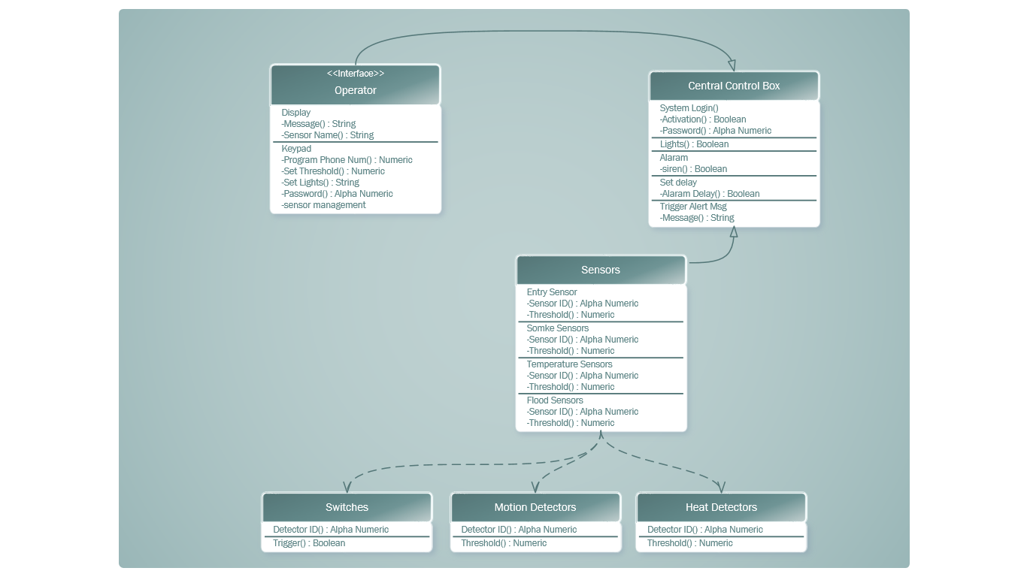

UML sequence diagrams to show how the program responds to an alarm being triggered, and how the operator can turn the system off.

